Orientation Leader Application
Office of Student Engagement
Student Leadership Center, Suite 204
10 Upper College Drive, Alfred, NY 14802
O: 607.587.4959 F: 607.587.3225
E: bumpce@alfredstate.edu

Contents in Orientation Leader Application
New Student Orientation Leader Application 2
Qualifications 3
Ideal Candidate 3
Job Responsibilities 3
Application Process 4
Important Dates to Consider: *Dates subject to change. Additional dates may be required. 4
Your application should include all the following: 4
General Application: 4
References 4
Orientation Leader General Application 6
Application Agreement 7
2025 Reference List Form 8
Rating of Candidate 9

New Student Orientation Leader Application

Thank you for expressing interest in becoming an Alfred State Orientation Leader. The Orientation Team is looking forward to an exciting year filled with many memorable experiences. We need your help in welcoming new students and their families during New Student Orientation 2025!
Applications must be returned to the Office of Student Engagement or emailed to bumpce@alfredstate.edu.
*Applications received will be considered until Thursday, January 30, 2025.

Alfred State’s New Student Orientation Team Mission

Alfred State College’s Orientation program enhances the relationship between new students and their families to the college community by creating opportunities to interact with the academic and social life of the college. Orientation is an experience that increases engagement with the college culture and promotes a successful transition to college life at Alfred State College.

Orientation Leader Testimonials

Being an Orientation Leader helped me grow as a person when it comes to leadership, maturity, and responsibility.
It also helped me get closer with my peers and become the first friend of a lot of new students. Which to me, is what the job is about. Your goal is to help these incoming students feel welcome and comfortable their first time away from home. ~ Cali Forrest, O.L. ‘24

Before I applied to be an Orientation Leader, I considered myself to be shy and kept to myself. Through the orientation experience I learned leadership skills on campus and to be confident in who I am and what I can bring to Alfred State. I believe orientation is a big reason I was able to come out of my personal bubble and make many more friendships and professional relationships than I ever thought that I would here in Alfred. ~ Dean Jackson, O.L. ‘24

Photos from summer 2024
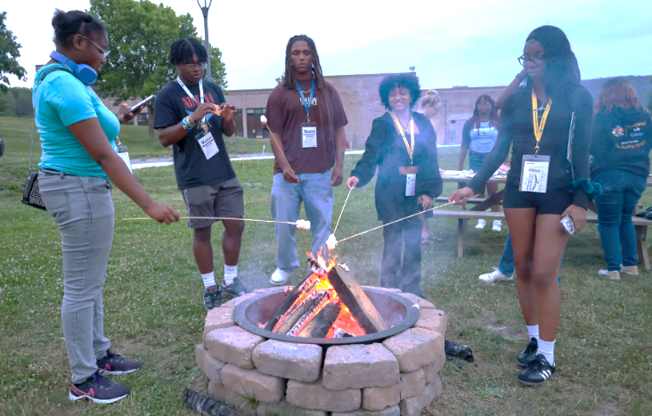
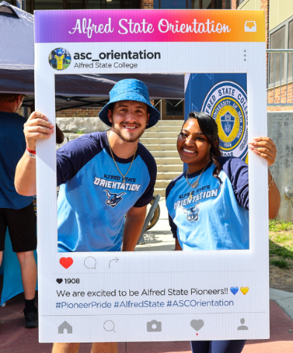

Qualifications
  - Applicants’ cumulative and semester grade point averages must be at or above 2.5.
  - Applicants must be considered full-time students for the fall 2025 semester or have been accepted by another SUNY institution. Full-time status is defined as 12 to 18 credit hours per semester.
  - Applicants must pass a background check that consists of but not limited to judicial offenses. This will be determined by the Office of Judicial Affairs and the Office of Student Engagement.
  - Applicants must be able to work individually and as a team member.

Ideal Candidate
  - Possess knowledge of and commitment to the mission and goals of New Student Orientation
  - Demonstrate leadership potential, professional demeanor, strong work ethic, a willingness to take initiative, and creative solutions to marketing events to new students
  - Exhibit a positive attitude, high energy level, knowledge of and enthusiasm for Alfred State
  - Work effectively with a diverse group of student leaders and professional staff
  - Show a desire to learn about Alfred State’s community, programs, resources, policies, and procedures
  - Be flexible, responsible, and eager to assist others.
  - Expose students to campus experiences as a Pioneer.
  - Affirm students’ choice to attend Alfred State College

Job Responsibilities
Responsibilities include, but are not limited to…
  - Attend and participate in all spring and summer training and program requirements (see important dates below)
  - Serve as a positive representative of Alfred State to new students and families
  - Answer questions about both social and academic aspects of life at Alfred State
  - Promote interaction among new students during small group discussions, icebreakers, meals, and activities
  - Assist new students with class registration during each Orientation session
  - Assist with coordinating and facilitating social activities for new students during Orientation and Week of Welcome
  - Work closely and cooperate with all members of the Orientation Team and Student Engagement staff to develop, prepare, implement, and evaluate Orientation programs
  - Provide administrative support for Orientation programs, including preparation of materials, phone calls, tours, etc.
  - Work with Student Engagement staff to assist with and support all aspects of New Student Orientation, including Week of Welcome, Bandwagon projects and January Orientation.

Application Process

Important Dates to Consider: *Dates subject to change. Additional dates may be required.
Thursday, January 30, 2025 | Orientation Leader Applications must be submitted.
Monday, February 3 – March 5, 2025 | Interviews (first and second round)
Friday, March 7, 2025 | Orientation Team Selection (notified via email)
Wednesday, March 19, 2025 | First Orientation Team meeting, time and location: TBD
Monday, March 24 – May 2, 2025 | Spring Onboarding & Training, dates and times, TBD
Monday, June 16 – August 24, 2025 | Summer Training, Orientation sessions, Week of Welcome
Friday, January 16, 2026 | Spring 2026 Orientation

- Acquire an application from the Office of Student Engagement (OSE) or JobLink or PioneerLink
  - Submit Application via email to bumpce@alfredstate.edu OR in-office to an OSE professional by 1/30/25.
  - Selection will be based on two rounds of interviews.

Your application should include all the following:
☐ General Application ☐ Application Agreement ☐ Questions

General Application: Please complete the attached application and make sure to sign the Application Agreement. Please answer the questions listed below on a separate document (i.e. doc, pdf) they MUST be typed and emailed to bumpce@alfredstate.edu to be considered for review by 1/30/25.
- Why are you interested in becoming an Orientation Leader?
- Based on your own experiences, what advice would you give a new student to improve their first few weeks on campus?
- Is the Orientation experience important for incoming students and their families? (Provide detailed explanation).
- What is one thing would you change about your experience here at Alfred State? Why?
- What makes you an ideal candidate for the Orientation Leader position? What unique characteristics and experiences will you contribute to the Orientation Team?

References: You are required to submit two references as part of your application. The references may be completed by a former employer, a student organization advisor, or another faculty/staff member who is familiar with your skill set/experience as it relates to serving as an Orientation Leader.

Your references must complete the 2025 Reference List Form below and submit it electronically to bumpce@alfredstate.edu or in person to the Office of Student Engagement by 1/30/25.

Please provide us with the following information about the individuals you selected to complete the attached 2025 Reference List Form.

Reference 1
Name: Click or tap here to enter text. | Position/Title: Click or tap here to enter text.
Email address:Click or tap here to enter text. | Phone Number:Click or tap here to enter text.
Reference 2
Name:Click or tap here to enter text. | Position/Title: Click or tap here to enter text.
Email address:Click or tap here to enter text. | Phone Number:Click or tap here to enter text.

Orientation Leader General Application
Name: Click or tap here to enter text.
College ID #: Click or tap here to enter text. |  | Date of Birth (mm/dd/yyyy): Click or tap to enter a date.
Type of Student Status: ☐ Residential ☐ Commuter ☐ Resi-muter (off-campus housing in Alfred)
Address 1: (campus if residential e.g. Mackenzie East G4C3) Click or tap here to enter text.
City:Click or tap here to enter text. |  |  | State: XX |  | Zip code:Click or tap here to enter text.
Address 2: (home)Click or tap here to enter text.
City:Click or tap here to enter text. |  |  | State: XX |  | Zip code: Click or tap here to enter text.
Cell phone: (e.g xxx.xxx.xxxx) | Email address: @alfredstate.edu
School of Study: ☐ SAMET ☐ SAS ☐ SAT |  | Major: Click or tap here to enter text.
Class status: ☐ FR ☐ SO ☐ JR ☐ SR |  | Expected graduation date: Click or tap to enter a date.
Are you an EOP Student? ☐ Y ☐ N |  | Are you an ASOP student? ☐ Y ☐N
Are you a First-Generation College Student? ☐ Y ☐ N
ASC defined First-Generation college students as being the first in their family to attend college. Siblings may also be attending a college or university, but neither parent has completed an Associate’s degree or higher.
Cumulative GPA: Click or tap here to enter text. |  | Last semester GPA: Click or tap here to enter text.
Have you ever been expelled/dismissed from a college/university for academic reasons? ☐ Y ☐ N
Have you ever been expelled/dismissed from a college/university for disciplinary reasons? ☐ Y ☐ N
Do you currently hold a job on campus? ☐ Y ☐ N
(if yes answer next two rows, if no skip to Transfer question)
Job Title: Click or tap here to enter text. |  |  |  | Job Location: Click or tap here to enter text.
Name of supervisor: Click or tap here to enter text. |  |  |  | Contact information:Click or tap here to enter text.
Are you a Transfer Student? ☐ Y ☐ N
(if yes answer next line, if no skip to “How did you hear about the position”)
Name of institution(s) attended:
Click or tap here to enter text.
Click or tap here to enter text.
Dates of attendance: Click or tap here to enter text.
How did you hear about the Orientation Leader position?
Click or tap here to enter text.

Application Agreement

This application is accurate to the best of my knowledge. The thoughts and words expressed in this application are my own. By signing and submitting this application, I agree to the Orientation Team mission, objectives, and responsibilities as outlined in this application. I authorize Student Engagement professional staff to verify the provided academic and judicial information. I understand that my academic and judicial standing will be verified each semester I am employed as an Orientation Leader. I understand that failing to comply with any of the Orientation Leader responsibilities as stated in this application or failing to represent and uphold the reputation of the Orientation Team may result in immediate dismissal.

Applicant’s Signature: Click or tap here to enter text. | Date:Click or tap to enter a date.

Thank you again for your interest in Alfred State’s Orientation Team. After the application has been received, you will be contacted by e-mail if selected to schedule an interview
Orientation Leader Application
Office of Student Engagement
Student Leadership Center, Suite 204
10 Upper College Drive, Alfred, NY 14802
O: 607.587.4959 F: 607.587.3225
E: bumpce@alfredstate.edu

2025 Reference List Form

Thank you for serving as a reference for an Orientation Leader candidate. By providing an honest appraisal regarding the strengths and weaknesses of the applicant, you will assist the Office of Student Engagement in the selection of Orientation Leaders for the summer of 2025.

Please complete and submit this form as soon as possible, the application deadline is January 30, 2025. Forms can be submitted electronically (include form as an attachment) to bumpce@alfredstate.edu, by fax to 607-587-3225 (to the attention of Calsey Bump), by mail to 10 Upper College Dr., Student Leadership Center, Alfred, NY 14802 (to the attention of Calsey Bump), or in person to the Office of Student Engagement in the Student Leadership Center, Suite 204.
Part A: Please share the requested information below. We may contact you for additional information or clarification.

Name of Applicant: | Click or tap here to enter text.
Name/Title of Evaluator | Click or tap here to enter text.
Email address: | Click or tap here to enter text.
Phone number: | Click or tap here to enter text.
How long have you known the applicant? | Click or tap here to enter text.
In what capacity? | Click or tap here to enter text.

Part B: Please make an honest judgment of the qualities the candidate possesses for effective work with new students and their families, professional staff members, and fellow Orientation Leaders. Please take a moment to consider the roles and responsibilities of Orientation Leaders (listed below) before evaluating the candidate. Your responses will not be shared with the applicant.

- Encourage new student participation in all Orientation programs and activities
- Acquaint new students with Alfred State
- Serve as positive representatives of Alfred State to new students and their families
- Answer students’ and families’ questions about social and academic aspects of campus life
- Assist with preparation of Orientation materials and activities
- Facilitate Icebreakers with small groups of new students during New Student Orientation sessions
- Work closely with fellow Orientation Team members

If you have any questions about the Orientation Leader position, please contact the Office of Student Engagement at 607-587-4075.

Rating of Candidate
Please select the most appropriate rating on the qualities and characteristics of the applicant below.
1= well below average, 2= below average, 3= average, 4= above average, 5= well above average/truly exceptional

Rating Scale | 1 | 2 | 3 | 4 | 5 | No Basis for Judgement
Maturity | ☐ | ☐ | ☐ | ☐ | ☐
Responsibility | ☐ | ☐ | ☐ | ☐ | ☐
Communication skills | ☐ | ☐ | ☐ | ☐ | ☐
Flexibility | ☐ | ☐ | ☐ | ☐ | ☐
Sound judgment | ☐ | ☐ | ☐ | ☐ | ☐
Leadership potential | ☐ | ☐ | ☐ | ☐ | ☐
Personal work ethic | ☐ | ☐ | ☐ | ☐ | ☐
Prioritizes multiple tasks | ☐ | ☐ | ☐ | ☐ | ☐
Works well under pressure | ☐ | ☐ | ☐ | ☐ | ☐
Works well in group/team | ☐ | ☐ | ☐ | ☐ | ☐
Scholastic achievement | ☐ | ☐ | ☐ | ☐ | ☐
Positive attitude | ☐ | ☐ | ☐ | ☐ | ☐
School pride/enthusiasm | ☐ | ☐ | ☐ | ☐ | ☐

Please elaborate on the above rankings (feel free to attach additional pages as needed):

Click or tap here to enter text.

Recommendation: Please indicate your overall recommendation for this candidate.

☐ Strongly recommend | ☐ Recommend
☐ Recommend with reservation (please elaborate below) | ☐ Do not recommend

Additional comments:
Click or tap here to enter text.

Signature: Click or tap here to enter text. | Date: Click or tap to enter a date.

Please complete and submit this form no later than 4:00 p.m., Thursday, January 30, 2025 (see above for submission instructions).

